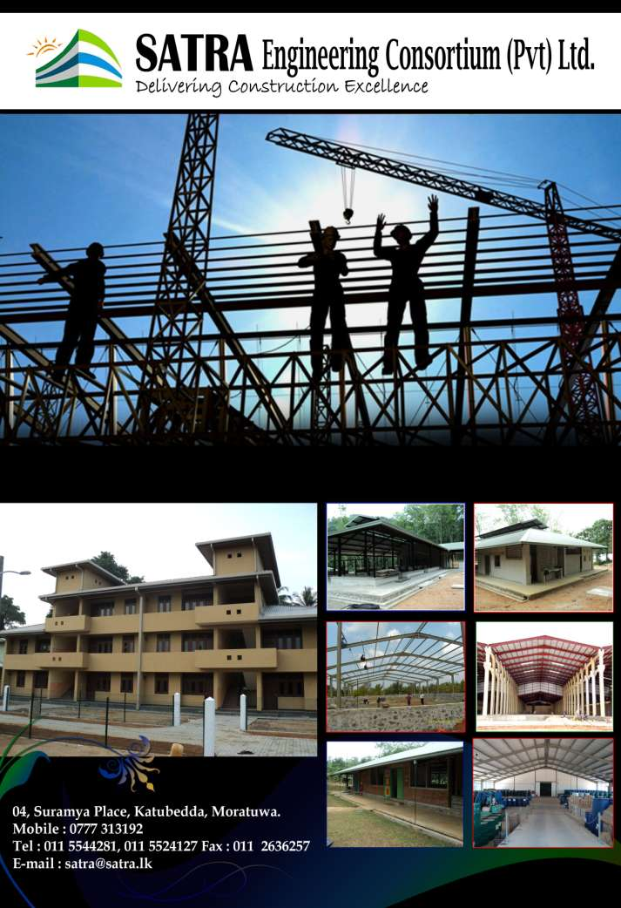

OUR VISION

Our vision is to become one of the top 10 Construction Company in Sri Lanka in
2020, delivering every project to the highest standard, with passion and professionalism using state of the art technology in exceeding client expectation.

OUR MISSION

▪  In developing an agreement with our customer in ensuring complete satisfaction with design and construction experience.

▪  In delivering uncompromising quality workmanship, on time and on budget, so that customers will have complete confidence and peace of mind throughout the entire construction.

▪  In managing all construction risks while planning ahead for reasonable contingencies in ensuring investor satisfaction for adverse and unfavorable conditions.

▪  To practice honesty at site and at negotiations, conduct our selves legally and ethically in earning fair returns on our investments.

▪  To focus on recruiting, developing and retaining employees with ability, skills and competency required to maintain the dynamic corporate culture driven by values and norms of the industry.

▪  To provide our employees with most effective tool and technologies required to further ensure safety of people, equipment and property at every stage in the construction.

▪  To manage design and construct buildings that would bring zero damage to the environment and nature while targeting zero disturbances to the society

❖ Quality Policy:

To be no 1 trusted company in setting standards.

To delight valued customers by providing quality product/services, effectively at their door step, at the required price and required time To inspire and empower employees to be achievers.

To maintain relationship with suppliers for mutual benefits. To achieve reasonable returns on investments.

To create a friendly environment.

To be a responsible corporate citizen.

❖ Environmental policy

Prevent pollution by utilizing natural recourses in an optimal manner to become an environmental friendly organization.
Comply with applicable environmental laws and regulations whilst maintaining a good environmental management system on ISO
14001:2004 international standard.
Improve our environment activities on continual basis with effective use of environmental management system.

HEALTH AND SAFETY

▪ Company is committed to take all possible steps to ensure the health, safety and welfare of all employees and other persons engaged in work for the organization and any third parties who came into contact with the business.

▪ It is the duty of each employee to comply with the company safety policy and to co-operate with the management of the company to ensure that the work place remains as safe as possible.

▪ Comply with applicable health and safety legislations.

▪ Company is fully committed to maintain safety systems of work and fully recognizes their overall responsibility for safety in the work place.

▪ Company is committed to improve the occupational health and safety system on a continual basis.

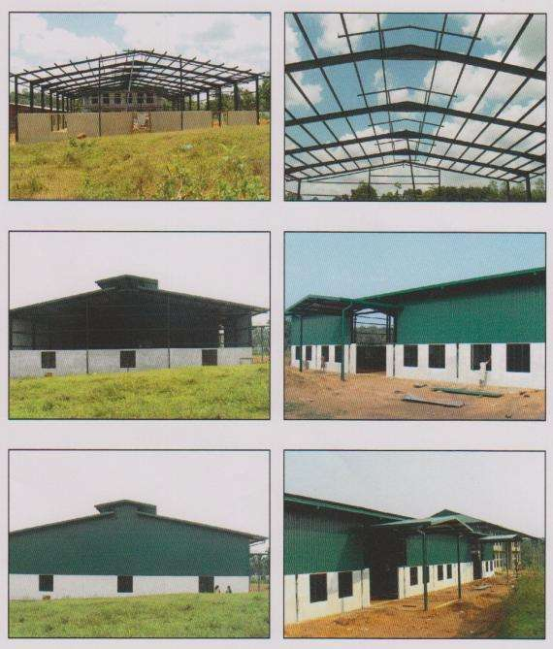

E.B.CREASY FACTORY COMPLEX FABRICATED AND INSTALLED BY SATRA AT PADUKKA AREA

(Square Feet)- 14000

M.S.CAPITAL MAHARAJ FACTORY COMPLEX FABRICATED AND INSTALLED BY SATRA AT DANKOTUWA AREA

(Square Feet)- 220000
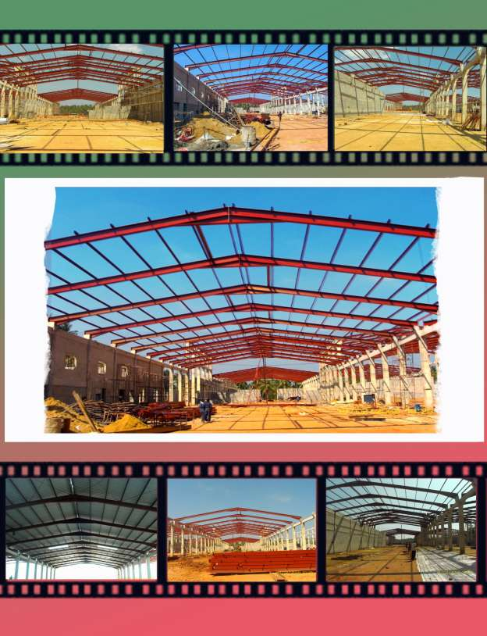

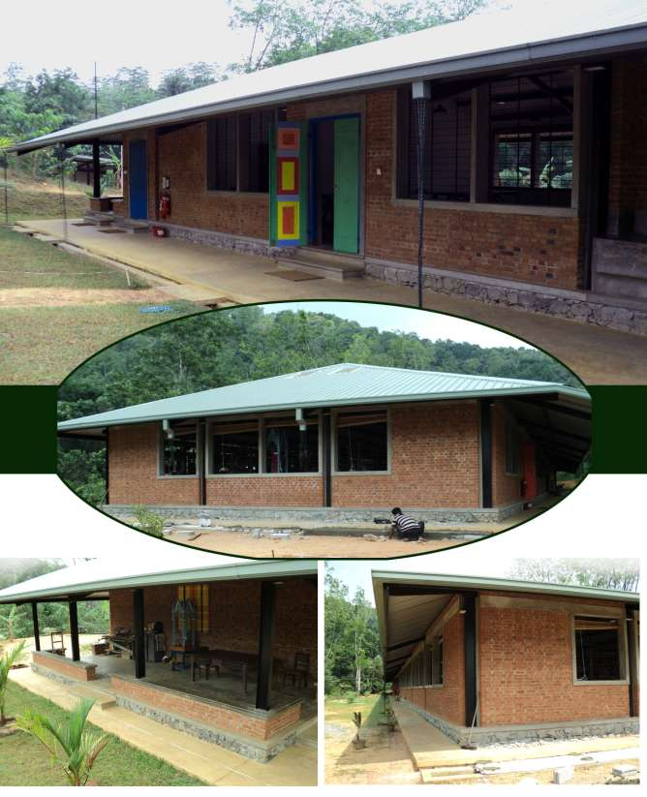

BAREFOOT WEAVING CENTER FABRICATED AND INSTALLED BY SATRA AT MEEPE AREA

(Square Feet)- 14200

IDP HOSPITAL
FABRICATED AND INSTALLED BY SATRA AT MANIQUE FARM AREA (Square Feet)- 1560

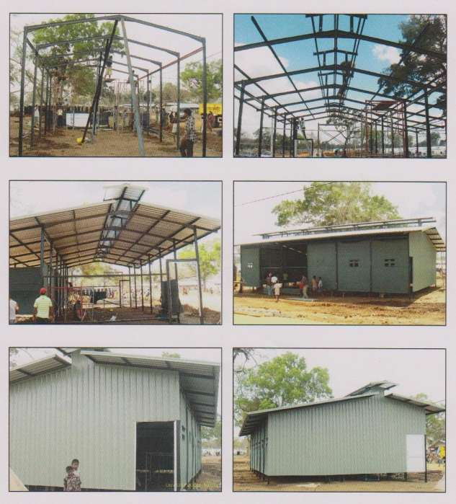

CIC HOUSE 2 STOREY RECORD ROOM FABRICATED AND INSTALLED BY SATRA AT PILIYANDALA AREA

(Square Feet)- 3000

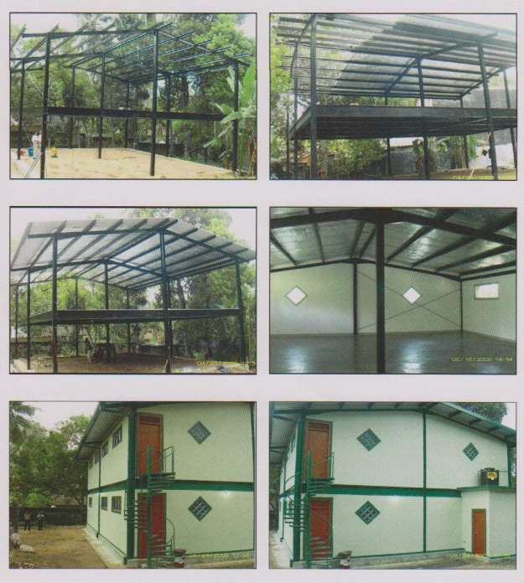

TOYMAKERS FACTORY COMPLEX FABRICATED AND INSTALLED BY SATRA AT

MADURANKULIYA AREA (Square Feet)- 15800

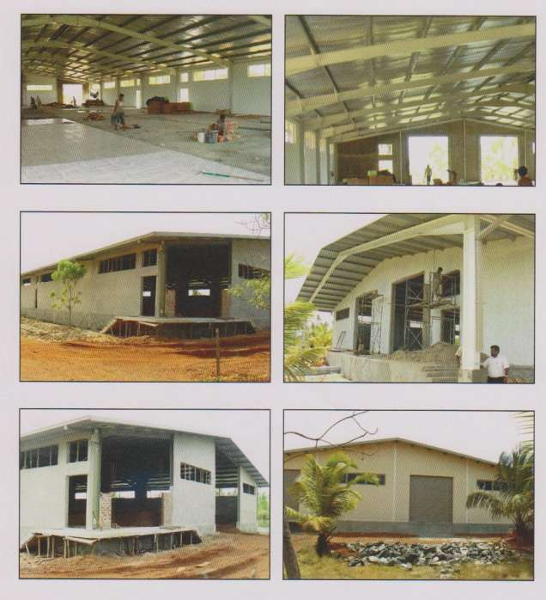

GARBAGE ROOM FOR CBL (PVT) LTD FABRICATED AND INSTALLED BY SATRA AT AWISSAWELA AREA

(Square Feet)-1090
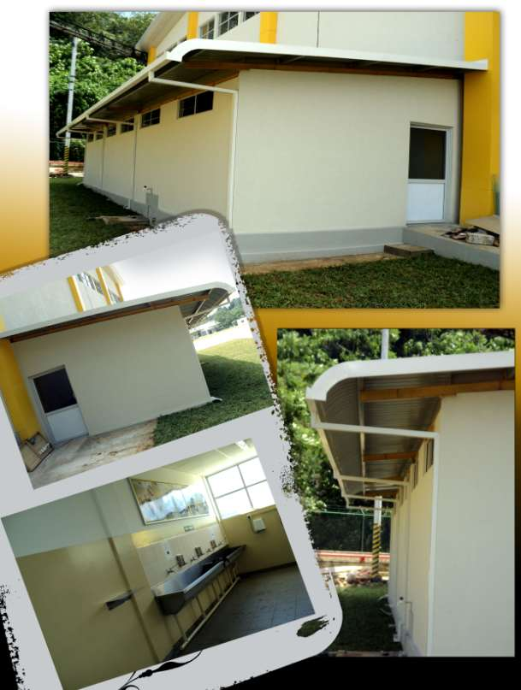

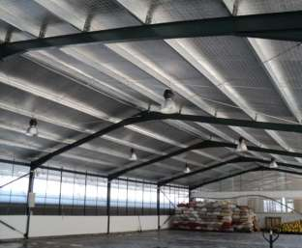

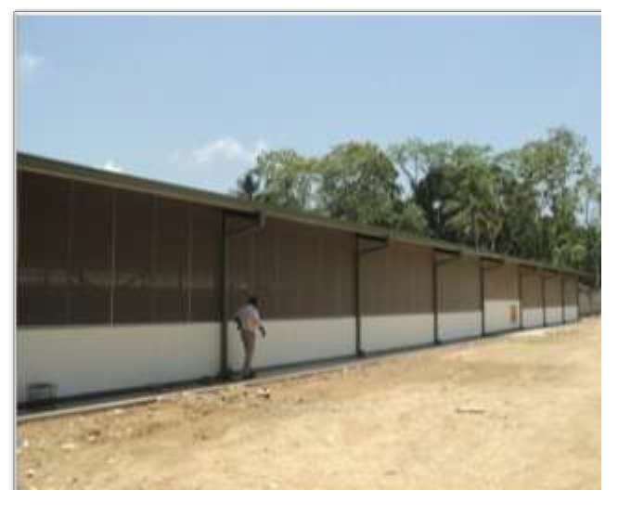

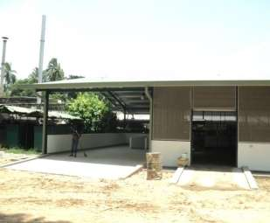

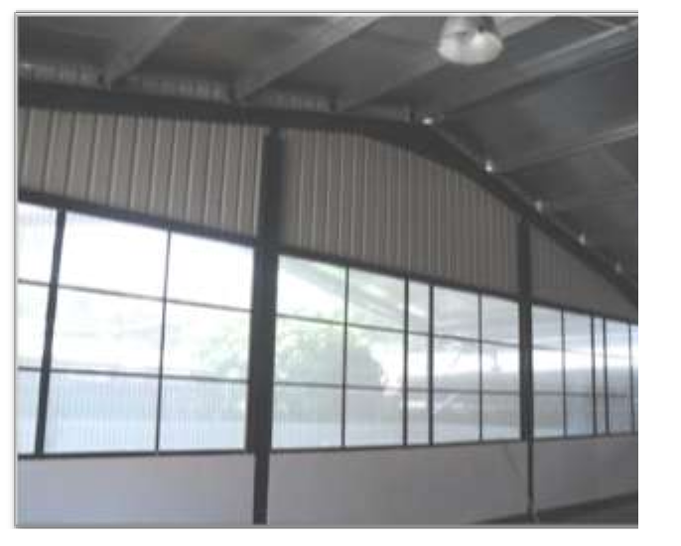

FRUIT STORES FOR CBL (PVT) LTD FABRICATED AND INSTALLED BY SATRA AT MINUWANGODA AREA

(Square Feet)-9000

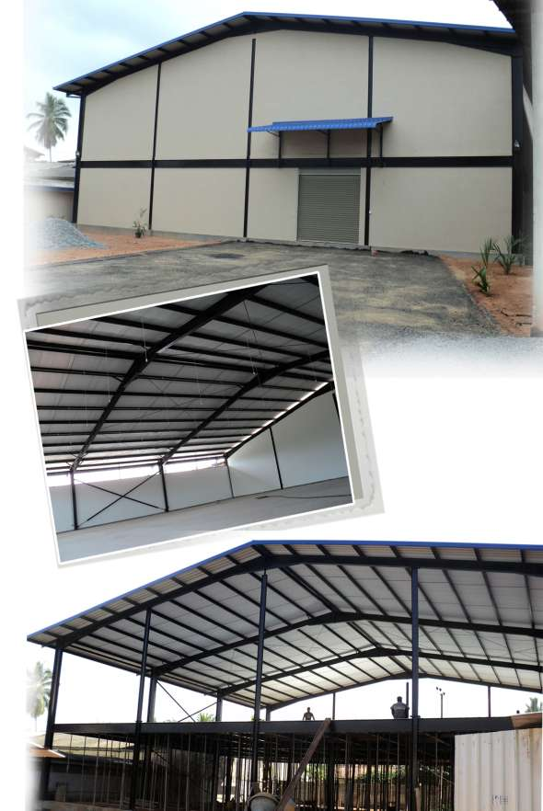

STORES BUILDING FOR CIC HOLDINGS PLC FABRICATED AND INSTALLED BY SATRA AT EKALA

KRB MONUMENT FOR CHINA GEO FABRICATED AND INSTALLED BY SATRA AT BIYAGAMA

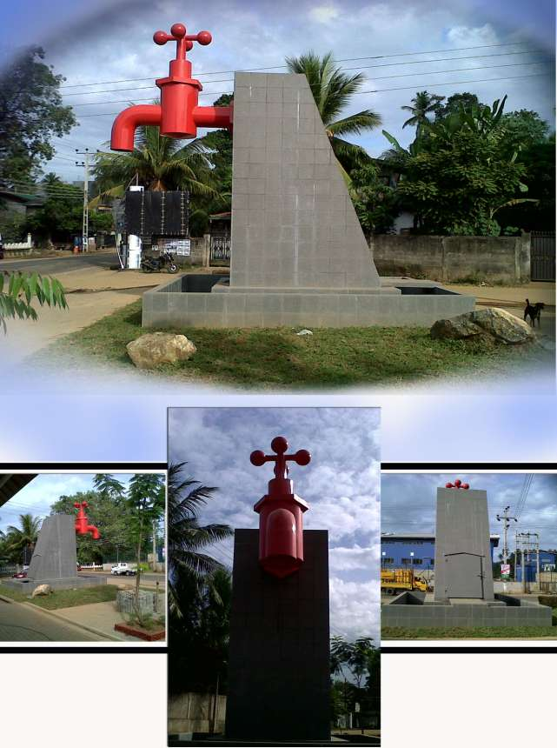

ENGINEERS QUARTERS FOR CHINA GEO CONSTRUCTED BY SATRA BIYAGAMA

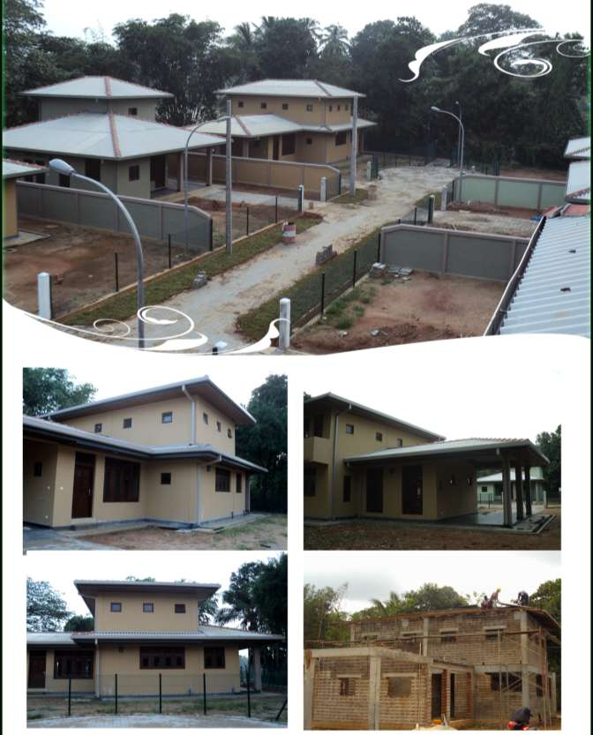

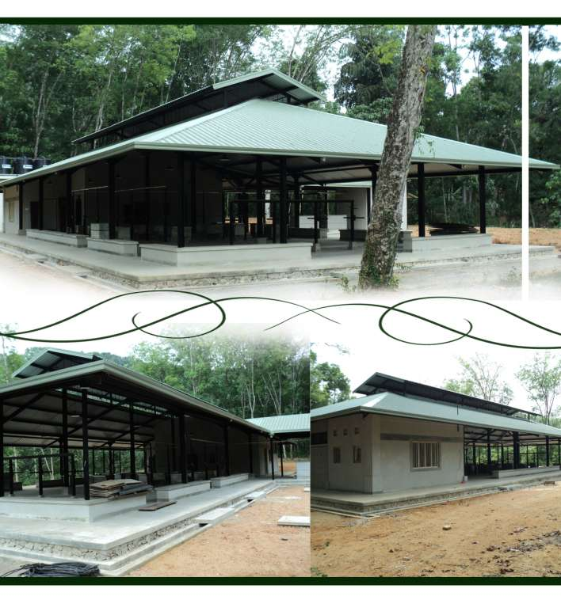

DYE PLANT AND BOILER ROOM FOR BAREFOOT FABRICATED AND INSTALLED BY SATRA AT MEEPE

OPERATORS QUARTERS FOR CHINA GEO CONSTRUCTED BY SATRA BIYAGAMA

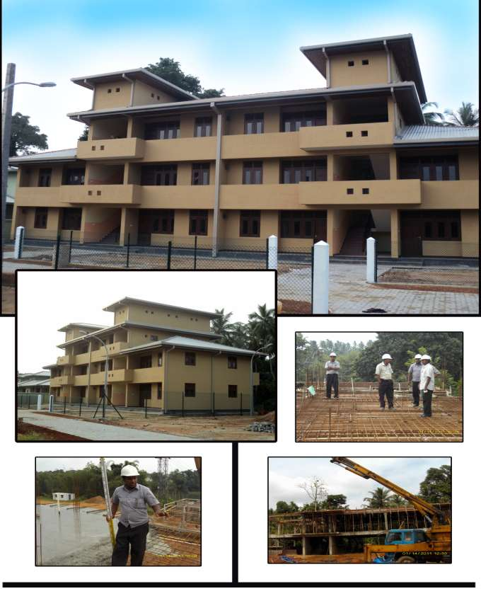

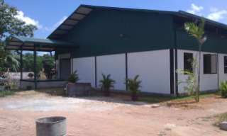

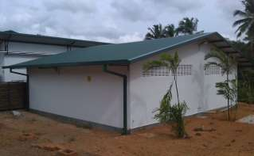

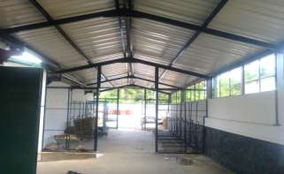

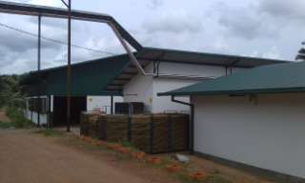

WORKERS REST ROOM AND SPECIAL STORAGE UNIT FOR EB CREASY
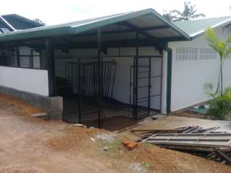

FABRICATED AND INSTALLED BY SATRA PADUKKA

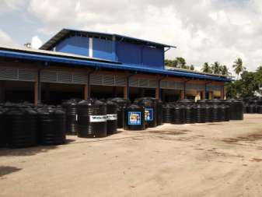

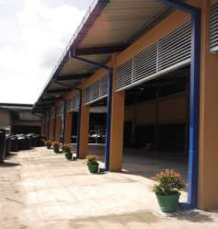

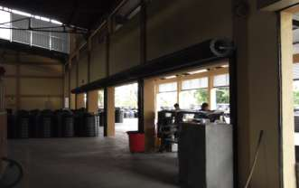

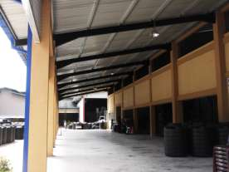

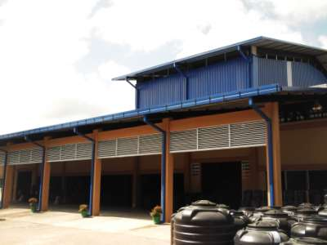

FACTORY EXTENTION PROJECT FOR
PE+ FABRICATED AND INSTALLED BY SATRA AT EKALA

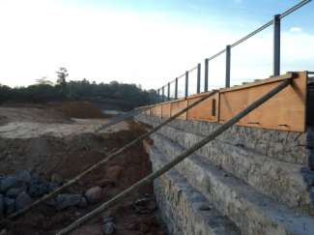

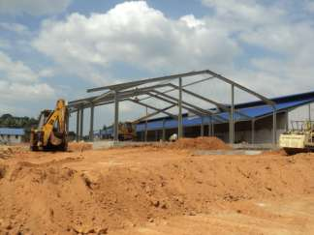

FINISHED GOOD BUILDING, RETAINING WALL AND RE PACKING FOUNDATION FOR CIC PROJECT BY SATRA AT PANAGODA
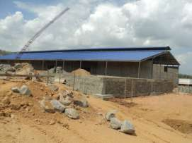

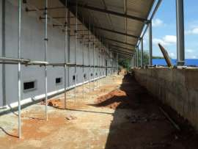

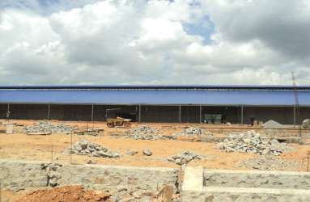

RAW MATERIAL BUILDING FOR CIC PROJECT BY SATRA AT PANAGODA
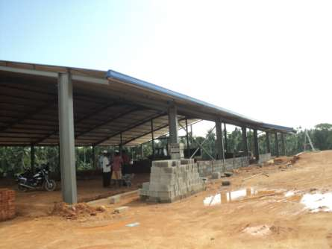

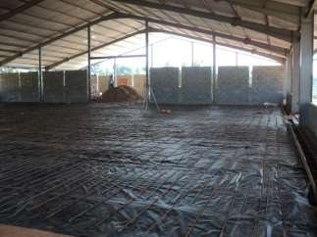
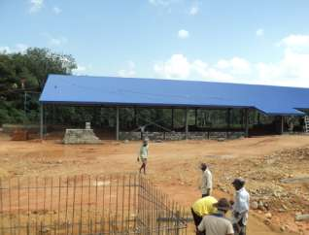

RAW MATERIAL BUILDING | _ | 1350(Square Feet)
REPACKING BUILDING | – | 1447 (Square Feet)
FINISHED GOOD BUILDING | – | 1350 (Square Feet)
PASSAGE AREA | – | 745 (Square Feet)

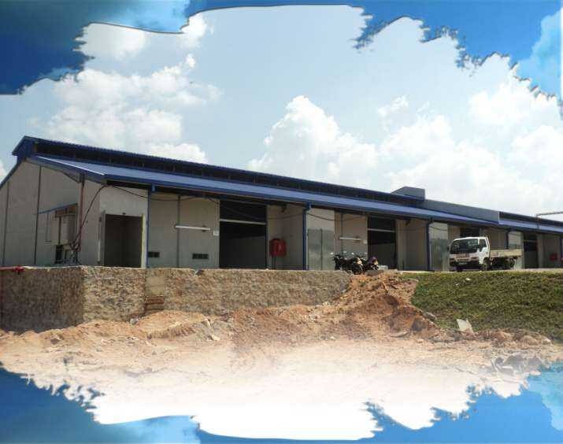

BUILDING FOR CIC PROJECT

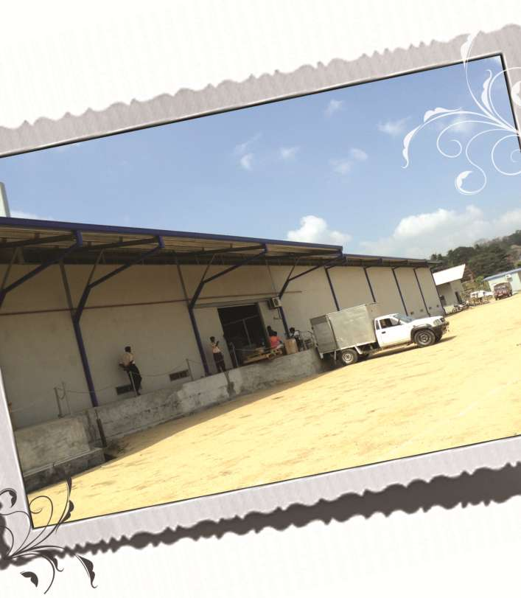

BUILDING FOR CIC PROJECT

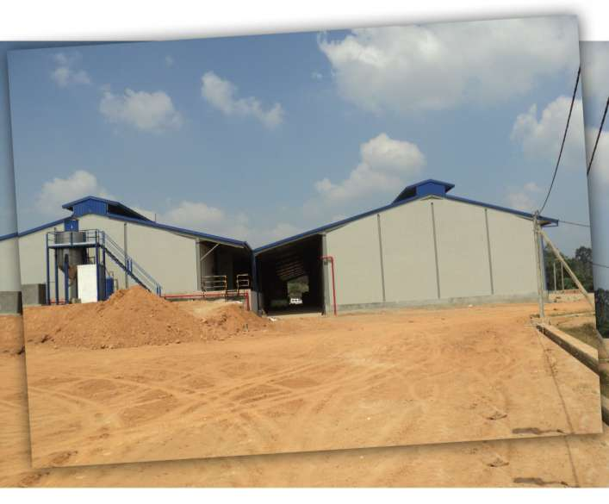

BUILDING FOR CIC PROJECT

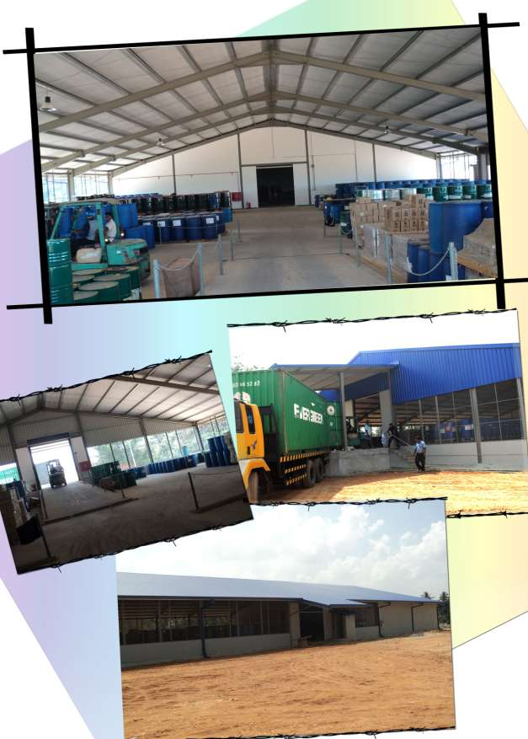

BUILDING FOR CIC PROJECT

LIST OF PROJECTS COMPLETED
SATRA ENGINEERING CONSORTIUM (PVT) LTD.

No | Project | Client | Location
1 | Factory Complex | M/S Capital Maharaja | Dankotuwa
2 | Housing Project | Estate Workers Housing | Bogawanthalawa
3 | Factory Complex | EB Creasy | Padukka
4 | Vehicle Shed Complex | Wheel Lanka Trading | Kirulapana
5 | Vehicle Shed Complex | Euro Motors Pvt Ltd | Peliyagoda
6 | Mosque | Markas Islamic Center | Grand Pass
7 | Cafeteria | Paradise Toys Pvt Ltd | Wattala
8 | Service Station | S.A.Developers | Pannipitiya
9 | Air Craft Hanger | Sky Line Aviation Pvt Ltd | Katukurunda
10 | Office Building Project | East West Marketing Pvt Ltd | Mattakkuliya
11 | Reception Hall | Mr.M.S.M.Fuward | Sarikkamulla
12 | Ware House | Mr.M.N.M.Remeeze | Mt. Lavinia
13 | Vehicle Parking Shed | Western Auto Lanka Pvt Ltd | Kelaniya
14 | Store Complex | International Cosmetic Ltd. | Ekala
15 | Factory Complex | Vinora Tea Factory | Baduraliya
16 | CIC -1 Two Story Record Room | C.I.C. House | Piliyandala
17 | 3 Hospital | CHA (Gte ) Ltd | Vavuniya
18 | Toilet Project | CHA (Gte ) Ltd (Unicef ) | Vavuniya
19 | Toilet Project | CHA (Gte ) Ltd (Unicef -IMOH ) | Vavuniya
20 | Toilet Project | CHA (GtE) Ltd (HNB) | Vavuniya
21 | Toymaker 01 -Factory Complex | Toymakers (Pvt) Ltd | Madurankuliya
22 | Toymaker 02 - Water Tank, Diesel Tank, Generator Room | Toymakers (Pvt) Ltd | Madurankuliya
23 | Toymaker 03 - Canteen Building | Toymakers (Pvt) Ltd | Madurankuliya
24 | Toymaker 04 - Factory Building | Toymakers (Pvt) Ltd | Madurankuliya
25 | Barefoot-01 - Handloom Weaving  Center | Barbara Sansoni Export (Pvt)Ltd | Meepe

LIST OF PROJECTS COMPLETED

SATRA ENGINEERING CONSORTIUM (PVT) LTD.

No | Project | Client | Location
26 | Barefoot-02 - Dye plant | Barbara Sansoni Export (Pvt)Ltd | Meepe
27 | Barefoot-03 - Boiler Room, Water Tank | Barbara Sansoni Export (Pvt)Ltd | Meepe
28 | CIC-02 - Lift Extension | Chemical Industries (Colombo) | Colombo
29 | CIC-03 - Gymnasium & Canteen | Chemical Industries (Colombo) | Colombo
30 | CIC- 4 - Roof Top office building | Chemical Industries (Colombo) | Ekala
31 | CIC-5 - Factory Building (Two storied Building) | Chemical Industries (Colombo) | Ekala
32 | China Geo - 1 ( Engineers  Quarters) | China Geo Engineering Corporation | Kelaniya, Biyagama
33 | China Geo - 2 ( Operators  Quarters) | China Geo Engineering Corporation | Kelaniya,  Biyagama
34 | EB Creasy - 2 | EB Creasy and company Ltd | Padukka
35 | Paradise Toys Reroofing | Toymakers (Pvt) Ltd | Madurankuliya
36 | China Geo Monument | China Geo Engineering Corporation | Biyagama
37 | EB Creasy - 3 | EB Creasy and company Ltd | Padukka
38 | EB Creasy - 4 | EB Creasy and company Ltd | Padukka
39 | CBL - 1 | Ceylon Biscuits Limited | Awissawela
40 | CBL - 2 | CBL Natural Foods Pvt Ltd | Minuwangoda
41 | CIC-6 & 8 | CIC Holdings PLC | Panagoda
42 | CIC - 7 | Chemical Industries (Colombo) | Panagoda
43 | PE PLUS | Capital Maharaja | Ekala
44 | CBL - 3 | CBL Natural Foods Pvt Ltd | Minuwangoda
45 | CBL - 4 | Ceylon Biscuits Limited | Pannipitiya
46 | RODESHA - 1 | Rodesha Enterprises | Anuradhapura
47 | TROPIC FISHERY | Tropic Fishery (Pvt) Ltd | Nigambo
48 | AUSLAN | Auslan International | Wathupitiwala
49 | IDM | IDM Computers | Colombo
50 | CIC - 9 | CIC Holdings PLC | Mahabage

LIST OF ON GOING PROJECTS
SATRA ENGINEERING CONSORTIUM (PVT) LTD.

No | Project | Client | Location
01 | DR PROJECT | Mr.Duminda Rathnayaka | Piliyandala
02 | EB CREASY - 6 | EB Creasy and company Ltd | Padukka
03 | LAXAPANA | Laxapana Batteries (Pvt) Ltd | Godagama

SATRA ENGINEERING CONSORTIUM (PVT) LTD MANAGEMENT STAFF

No | Name | Designation | Qualifications
1 | Anilal Rodrigo | Manging Director | Electrical Engineering CEI London / PGD in Marketing & Finance
2 | H.Suminda Ranjith Nonis | Director Operations | Professional Development Programm in  Project Management at NIBM
3 | Ashira Rodrigo | Finance Manager | Bsc. (Hons.) in Information Technology/ Association of Chartered Certified Accounts (Skill Level)
4 | Naveendra Perera | Project Manager | PGD (PM) Ad.dip(PM) Dip (Civil)AM (IIESL)
5 | J.A.I.S.U. Jayasuriya | Human Resources Manager | Professional Qualification in Human  Resources Management (IPM) / CCHRM (IPM) / NCIT Civil Engineering  / City & Guilds Adv. Dip.Civil
6 | Faizal Mowjood | Sales Manager | Diploma In Business Marketing  Chisholm Institute of TAFE, Australia.
7 | B.T.Harsha Fernando | Assistant Manager Supplier | Msc/PGD Dip/PGD Cert. in Business  Psychology (UK) /AB Economics (UK) /  BCS (UK)
8 | L.P.Nisal Buddika | Assistant Engineer - Civil | National Certificate in Quantity Surveyor / BTECH Engineering
9 | W.P.Mohan Kanishka | Assistant Engineer - Civil | NCE Draughtsmanship/ National  Certificate in Quantity Surveyor / N.C.T  (Civil)
10 | M.N.M.Riyas | Assistant Manger Sales & Operations | Diploma in Marketing
11 | W.P.G.Sarath Kumara | Assistant Engineer Fabrication | G.C.E Adv  ance Level
12 | R.H.Samitha Madushanka | Senior Site Coordinator | N.C.T (Civil), Civil Draughtsmannship
13 | R.A.N Indika Gunarathne | Senior Site Coordinator | N.C.T (Civil)
14 | K.D.Tharindu Wijewardena | Site Coordinator | NCIT Civil Engineering/ City & Guilds  Advance Technician Diploma in  Construction

SATRA ENGINEERING CONSORTIUM (PVT) LTD STAFF DETAILS

No | Name | Designation | Qualifications
15 | S.H.W.C.Samali | Senior Quantity Surveyor | NCT( Quantity Surveying) / NCE Draughtsmanship/National Diploma in Quantity Surveyor
16 | Lashini Wijekoon | Quantity Surveyor | NCIT Civil Engineering, City and Guilds  Advanced Diploma
17 | W.C.D.Nawarathne | Quantity Surveyor | National Certificate in Quantity Surveyor
18 | R.Dinuk Ranasinghe | Quantity Surveyor | HND Quantity Surveyor & Construction Economics/Bsc.(Hons) Commercial Management (QS)
19 | K.I. Vasantha Wijeyasinghe | Auto Cad Draftsman | Diploma in Auto Cad Draftsmanship
20 | D.M.P.R.Jayasinghe | Auto Cad Draftsman | Certificate in Eng. Draughtsmanship / NCT Civil Engineering
19 | Nadeesha Udayangani | Auto Cad Draftsman | NCE Draughtsmanship / N.C.T (Civil)
20 | Nuwanthi Kumarasiri | Project Assistance | NCE Draughtsmanship / N.C.T (Civil)
21 | A.Tharindu Nilukshi Perera | Assistant Manager Human Resources | FCHRM / CCHRM/ / PQHRM (Stage – 01) AAT part 1
22 | Sachithra Wimalasiri | Secretary | Institute of Chartered Corporate Secretary's/CIMA Foundation/Advance English In NIBM/Certificate of Computer Science in NIBM
23 | A.W.S.S.Mendis | Accounts Assistant | GCE A/L , AAT part 1

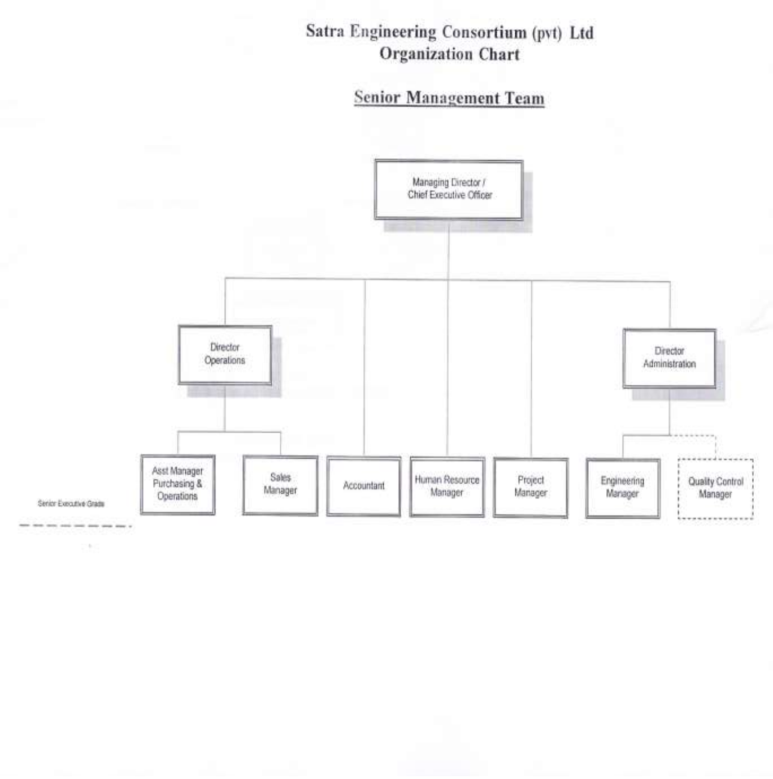
Figure 1

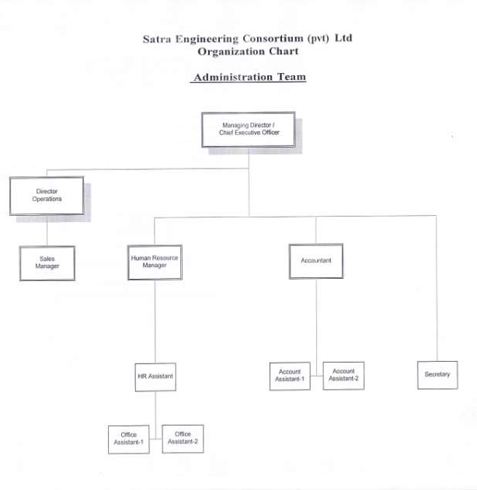

Supervisor Grade

Worker Grade

Senior Executive Grade

Junior Executive Grade

Senior Executive Grade

Junior Executive Grade

Supervisor Grade
